Quay Registry

1) stand alone quay registry setup

https://ncrtcocpreg1:8443 (https://10.200.11.121:8443) init L3s8UBZ0hPHvA97mM5W1VaoOKuYC26N4

registry setup steps
https://sharepoint.esds.co.in/_layouts/15/WopiFrame.aspx?sourcedoc={021133f4-82a3-467f-96b2-be62796b29f2}&action=default

Quay Registry Sync

https://sharepoint.esds.co.in/_layouts/15/WopiFrame.aspx?sourcedoc={6fe0378b-d5b4-438e-88f2-59fcc6c1719c}&action=default

vi registryrepomirror.yaml

apiVersion: operator.openshift.io/v1alpha1
kind: ImageContentSourcePolicy
metadata:
name: mirror-ocp
spec:
repositoryDigestMirrors:
- mirrors:
- ncrtcocpreg1.ncrtc.co.in:8443/openshift/release
source: quay.io/openshift-release-dev/ocp-release
- mirrors:
- ncrtcocpreg1.ncrtc.co.in:8443/openshift/release
source: quay.io/openshift-release-dev/ocp-v4.0-art-dev

cd /etc/docker/certs.d/

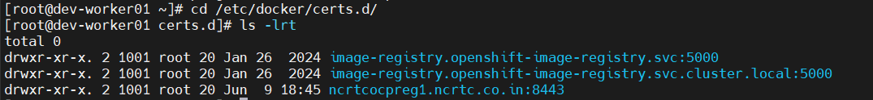

cat /var/lib/kubelet/config.json
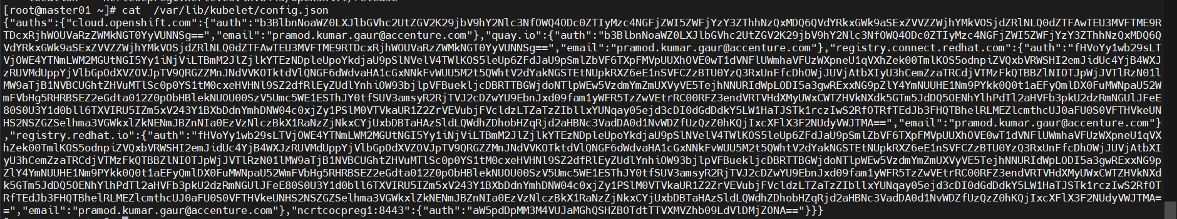

cat /etc/containers/registries.conf
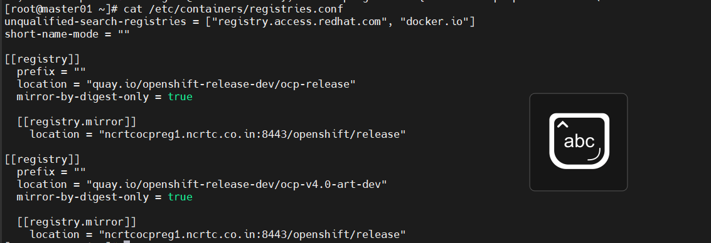

oc get secret pull-secret -n openshift-config -o json | jq -r '.data.".dockerconfigjson"' | base64 -d

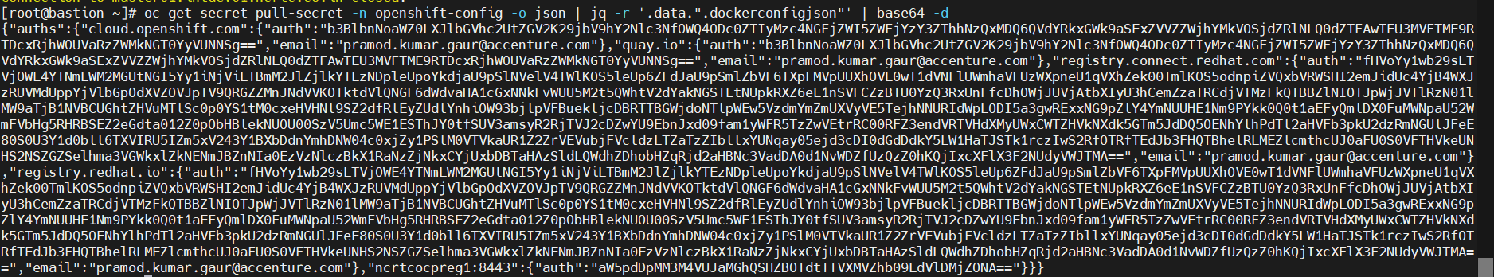

sudo cp /root/mirrorregistry_conf/ncrtcocpreg1.pem /etc/pki/ca-trust/source/anchors/

podman login ncrtcocpreg1:8443

podman search ncrtcocpreg1:8443/rhel8/redis-6 --list-tags

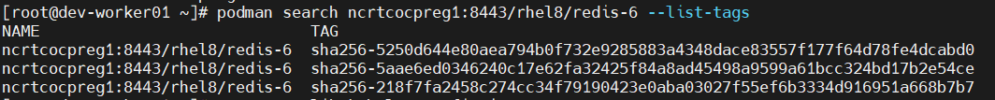

podman run -it --rm ncrtcocpreg1:8443/rhel8/redis-6:sha256-5250d644e80aea794b0f732e9285883a4348dace83557f177f64d78fe4dcabd0/bin/bash

